**EXPERIMENT:2**

**DATE: 05-08-2024**

**DATA MANIPULATIONS**

Create the following tables with the given structure.

**EMPLOYEES TABLE**

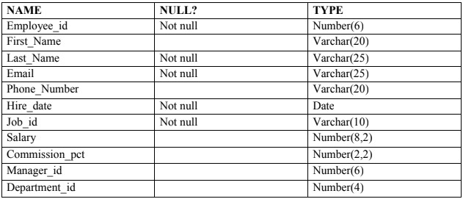

create table EMPLOYEES(EMPLOYEE_ID Number(6) Not null, FIRST_NAME Varchar(20),LAST_NAME Varchar(25) Not null, EMAIL Varchar(25) Not null, PHONE_NUMBER Varchar(20),HIRE_DATE Date Not null , JOB_ID Varchar(10) not null,

SALARY Number(8,2),COMMISSION_PCT Number(2,2),MANAGER_ID

Number(6),DEPARTMENT Number(4));

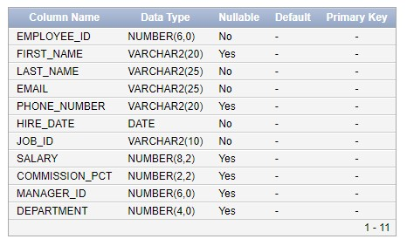

INSERT INTO Employees (EMPLOYEE_ID, FIRST_NAME, LAST_NAME, EMAIL, PHONE_NUMBER, HIRE_DATE, JOB_ID, SALARY, COMMISSION_PCT, MANAGER_ID, DEPARTMENT) VALUES

(1, 'PRIYA', 'MOHAN', 'priya@gamil.com', 'IN001', TO_DATE('09/22/2004',

'MM/DD/YYYY'), 'CS001', 53453, 0.2, 100, 60),

(2, 'JACK', 'STEVE', 'jack@gmail.com', 'IN002', TO_DATE('08/06/2001', 'MM/DD/YYYY'), 'DE002', 4556, 0.09, 100, 30),

(5, 'SREE', 'NIDHI', 'nidhi@gmail.com', 'IN023', TO_DATE('07/23/2000', 'MM/DD/YYYY'), 'EC124', 4355, 0.09, 110, 50),

(6, 'THENU', 'RAVI', 'thenu@gmail.com', 'IN231', TO_DATE('01/09/2002', 'MM/DD/YYYY'), 'CS002', 41323, 0.2, 110, 60),

(3, 'JOEL', 'AUSTIN', 'austin@gmail.com', 'US003', TO_DATE('09/07/2000', 'MM/DD/YYYY'), 'CS004', 3242, 0.4, 103, 80),

(4, 'TOM', 'TONKS', 'tom@gmail.com', 'IT023', TO_DATE('04/18/2020', 'MM/DD/YYYY'), 'AV021', 32643, 0.02, 102, 70);

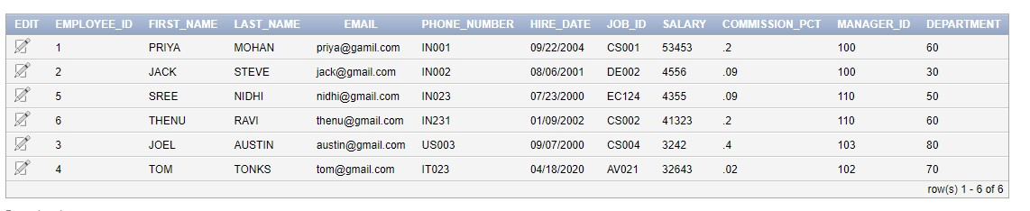

1. Find out the employee id, names, salaries of all the employees

SELECT Employee_id, First_Name, Last_Name, Salary FROM EMPLOYEES;

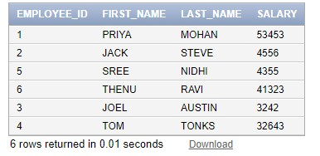

1. List out the employees who works under manager 100

SELECT Employee_id, First_Name, Last_Name FROM EMPLOYEES WHERE Manager_id =

100;

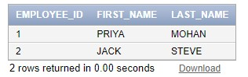

1. Find the names of the employees who have a salary greater than or equal to 4800

SELECT First_Name, Last_Name FROM EMPLOYEES WHERE Salary >= 4800;

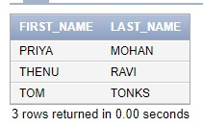

SELECT Employee_id, First_Name, Last_Name FROM EMPLOYEES WHERE Last_Name = 'AUSTIN';

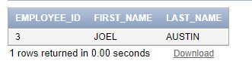

(e) Find the names of the employees who works in departments 60,70 and 80

SELECT First_Name, Last_Name FROM EMPLOYEES WHERE Department_id IN (60, 70,

80);

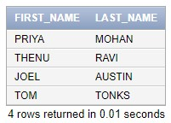

(f ) Display the unique Manager_Id.

SELECT DISTINCT Manager_id FROM EMPLOYEES WHERE Manager_id IS NOT NULL;

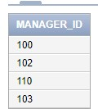

Create an Emp table with the following fields: (EmpNo, EmpName, Job,Basic, DA, HRA,PF,

GrossPay, NetPay) (Calculate DA as 30% of Basic and HRA as 40% of Basic)

CREATE TABLE EMP1 (

EmpNo INT PRIMARY KEY, EmpName VARCHAR(100), Job VARCHAR(50),

Basic DECIMAL(10, 2),

DA DECIMAL(10, 2),

HRA DECIMAL(10, 2),

PF DECIMAL(10, 2),

GrossPay DECIMAL(10, 2),

NetPay DECIMAL(10, 2)

);

UPDATE Emp1

SET DA = Basic * 0.30,

HRA = Basic * 0.40,

GrossPay = Basic + DA + HRA,

NetPay = GrossPay - PF;

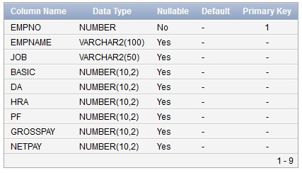

1. Insert Five Records and calculate GrossPay and NetPay.

INSERT INTO emp1 (EMPNO, EMPNAME, JOB, BASIC, PF) VALUES

(2, 'STEVE', 'DESIGNER', 20000, 5000),

(3, 'THENU', 'HR', 15000, 2000),

(4, 'SANDY', 'ANALYST', 25000, 4000),

(5, 'TOM', 'BUSINESS', 30000, 7000),

(1, 'PRIYA', 'CYBER', 10000, 5000);

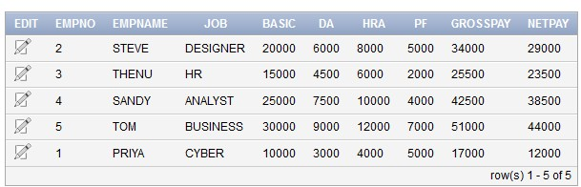

1. Display the employees whose Basic is lowest in each department.

SELECT EmpNo, EmpName, Job, Basic, DA, HRA, PF, GrossPay, NetPay FROM Emp1 WHERE (Job, Basic) IN (SELECT Job, MIN(Basic) FROM Emp1 GROUP BY Job);

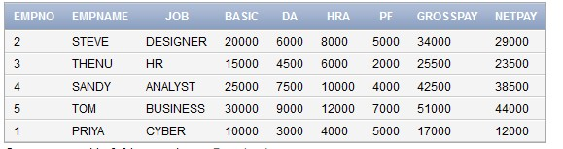

( c ) If Net Pay is less than 40000

SELECT EmpNo, EmpName, Job, Basic, DA, HRA, PF, GrossPay, NetPay FROM Emp1 WHERE NetPay < 40000;

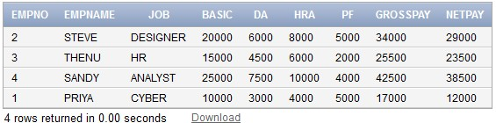

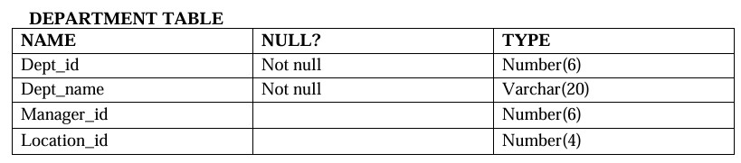

CREATE TABLE Department (

Dept_id NUMBER(6) NOT NULL,

Dept_name VARCHAR2(20) NOT NULL,

Manager_id NUMBER(6),

Location_id NUMBER(4),

PRIMARY KEY (Dept_id)

);

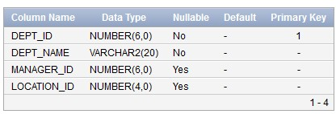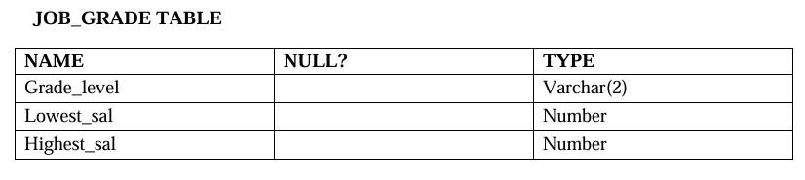

CREATE TABLE JOB_GRADE (

Grade_level VARCHAR2(2),

Lowest_sal NUMBER,

Highest_sal NUMBER

);

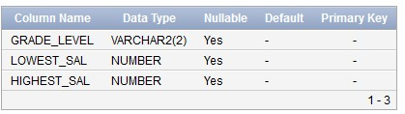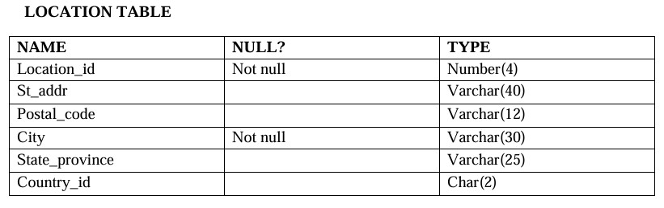

CREATE TABLE LOCATION (

Location_id NUMBER(4) NOT NULL,

St_addr VARCHAR2(40),

Postal_code VARCHAR2(12),

City VARCHAR2(30) NOT NULL,

State_province VARCHAR2(25),

Country_id CHAR(2),

PRIMARY KEY (Location_id)

);

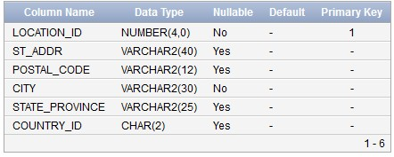

1. Create the DEPT table based on the DEPARTMENT following the table instance chart below. Confirm that the table is created.

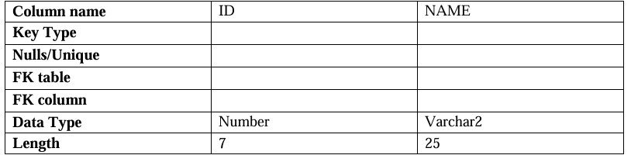

CREATE TABLE DEPT1 (

ID NUMBER(7) NOT NULL,

NAME VARCHAR2(25) NOT NULL,

PRIMARY KEY (ID)

);

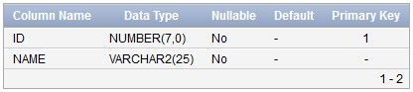

SELECT table_name

FROM user_tables

WHERE table_name = 'DEPT1';

1. Create the EMP table based on the following instance chart. Confirm that the table is created.

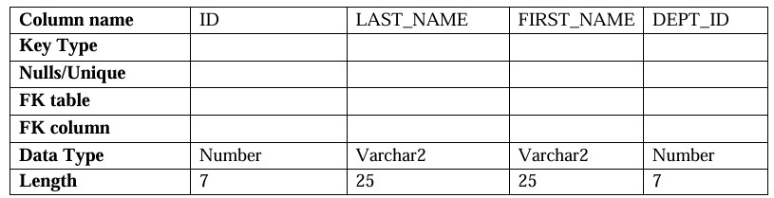

CREATE TABLE EMP2 (

ID NUMBER(7) NOT NULL,

LAST_NAME VARCHAR2(25) NOT NULL,

FIRST_NAME VARCHAR2(25),

DEPT_ID NUMBER(7),

PRIMARY KEY (ID)

);

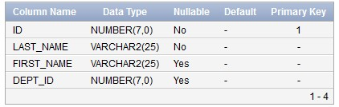

SELECT table_name

FROM user_tables

WHERE table_name = 'EMP';

1. Modify the EMP table to allow for longer employee last names. Confirm the modification.(Hint: Increase the size to 50)

ALTER TABLE EMP2 MODIFY (LAST_NAME VARCHAR2(50));

SELECT column_name, data_type, data_length

FROM user_tab_columns

WHERE table_name = 'EMP2'

AND column_name = 'LAST_NAME';

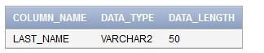

1. Create the EMPLOYEES2 table based on the structure of EMPLOYEES table. Include Only the Employee_id, First_name, Last_name, Salary and Dept_id coloumns. Name the columns Id, First_name, Last_name, salary and Dept_id respectively.

CREATE TABLE EMPLOYEES2 (

Id NUMBER(6) PRIMARY KEY, -- Corresponds to Employee_id

First_name VARCHAR2(20), -- Corresponds to First_Name Last_name VARCHAR2(25) NOT NULL, -- Corresponds to Last_Name salary NUMBER(8, 2), -- Corresponds to Salary Dept_id NUMBER(4) -- Corresponds to Department_id

);

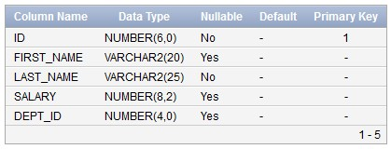

1. Drop the EMP table.

DROP TABLE EMP2;

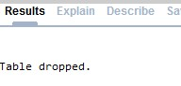

1. Rename the EMPLOYEES2 table as EMP.

ALTER TABLE EMPLOYEES2 RENAME TO EMP2;



1. Add a comment on DEPT and EMP tables. Confirm the modification by describing the table.

COMMENT ON TABLE DEPT1 IS 'Department details';

COMMENT ON TABLE EMP2 IS 'Employee details';

SELECT table_name, comments

FROM user_tab_comments

WHERE table_name IN ('DEPT1', 'EMP2');

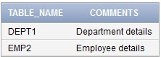

1. Drop the First_name column from the EMP table and confirm it.

ALTER TABLE EMP DROP COLUMN FIRST_NAME;

SELECT column_name

FROM user_tab_columns

WHERE table_name = 'EMP2';

